DAILY ASSESSMENT FORMAT

|  |  |  |  |
| --- | --- | --- | --- |
| Date: | 19 JUNE 2020 | Name: | Persis P |
| Course: | C PROGRAMMING | USN: | 4AL17EC069 |
| Topic: | BASICS | Semester & Section: | 6TH B |
| Github  Repository: |  |  |  |

|  |
| --- |
| FORENOON SESSION DETAILS |
| Image of session |
| Report – Report can be typed or hand written for up to two pages.      Conditionals      Conditionals are used to perform different computations or actions depending on whether a condition evaluates to true or false.    The if Statement |

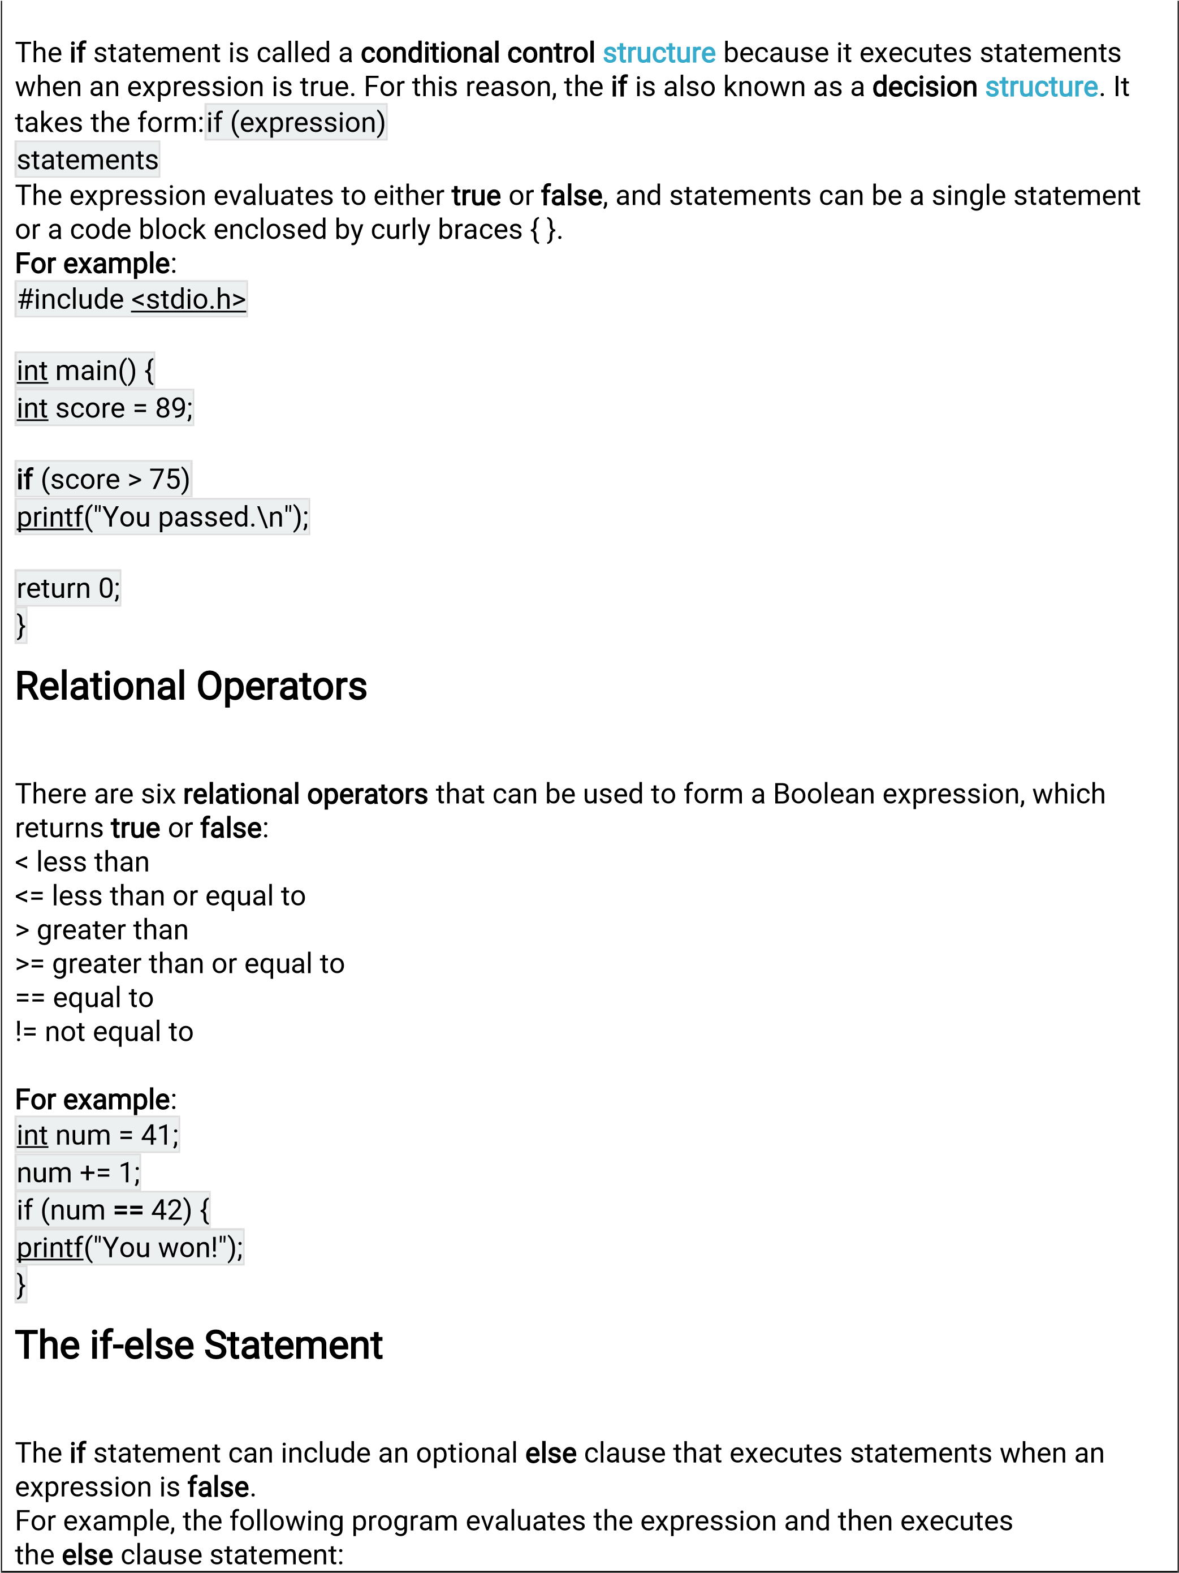

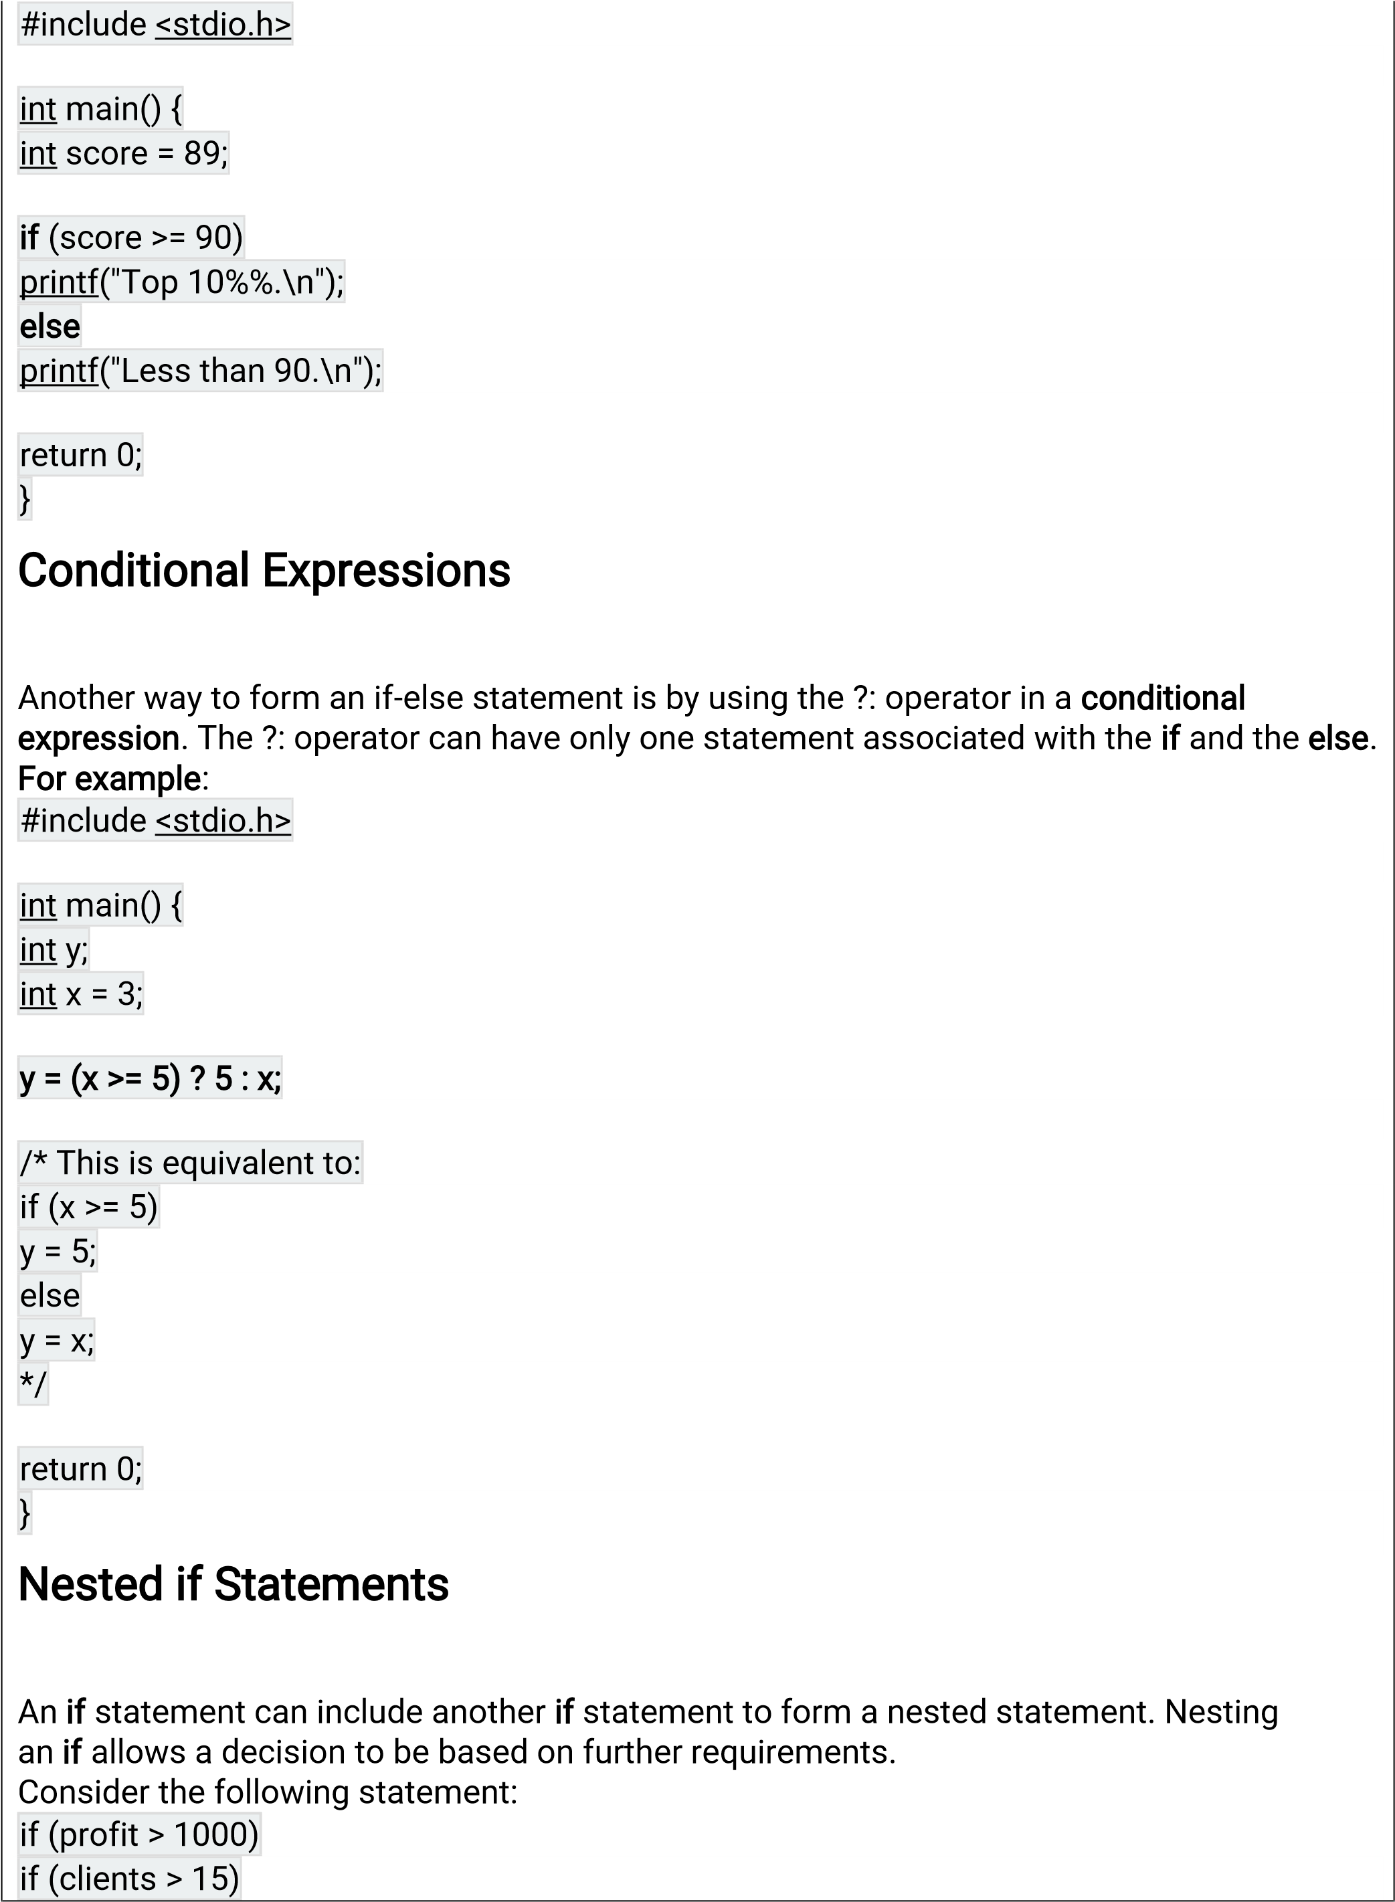

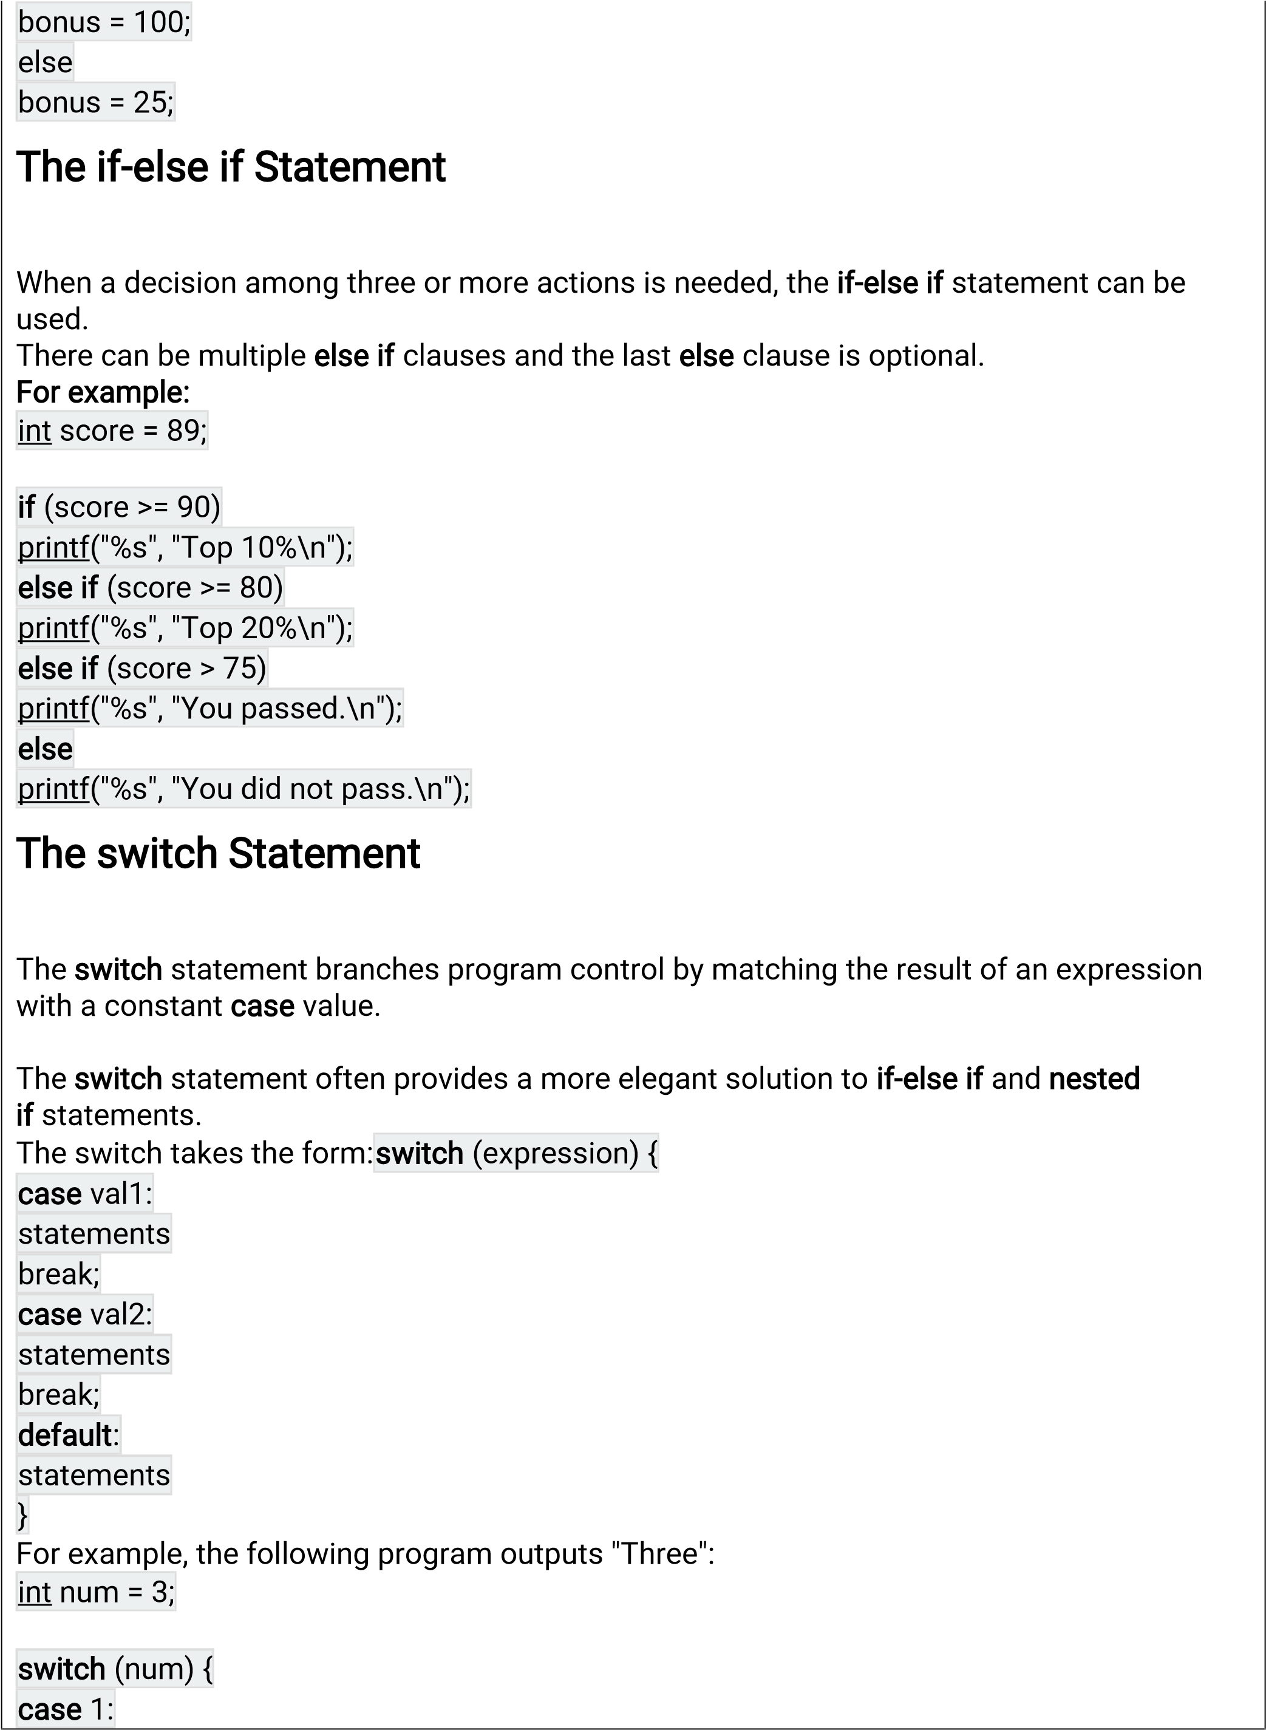

|  |  |  |  |  |  |  |  |
| --- | --- | --- | --- | --- | --- | --- | --- |
|  | printf("One\n"); | | |  | | | |
| |  | | --- | | break; | |  | | | | |  |
| |  | | --- | | case 2: | | |  | | | |
| |  | | --- | | printf("Two\n"); | | | |  | | |
| |  | | --- | | break; | |  | |
| |  | | --- | | case 3: | | |  |
| |  | | --- | | printf("Three\n"); | | | | |  | |
| |  | | --- | | break; | |  | | |
| |  | | --- | | default: | | |  | |
| printf("Not 1, 2, or 3.\n"); | | | | |  |
|  | | | | |
| }  The switch Statement  There can be multiple cases with unique labels.  The optional default case is executed when no other matches are made.  A break statement is needed in each case to branch to the end of the switch statement.  Without the break statement, program execution falls through to the next case statement. This can be useful when the same statement is needed for several cases. Consider the following switch statement:  Logical Operators  Logical operators && and || are used to form a compound Boolean expression that tests multiple conditions. A third logical operator is ! used to reverse the state of a Boolean | | | | | |

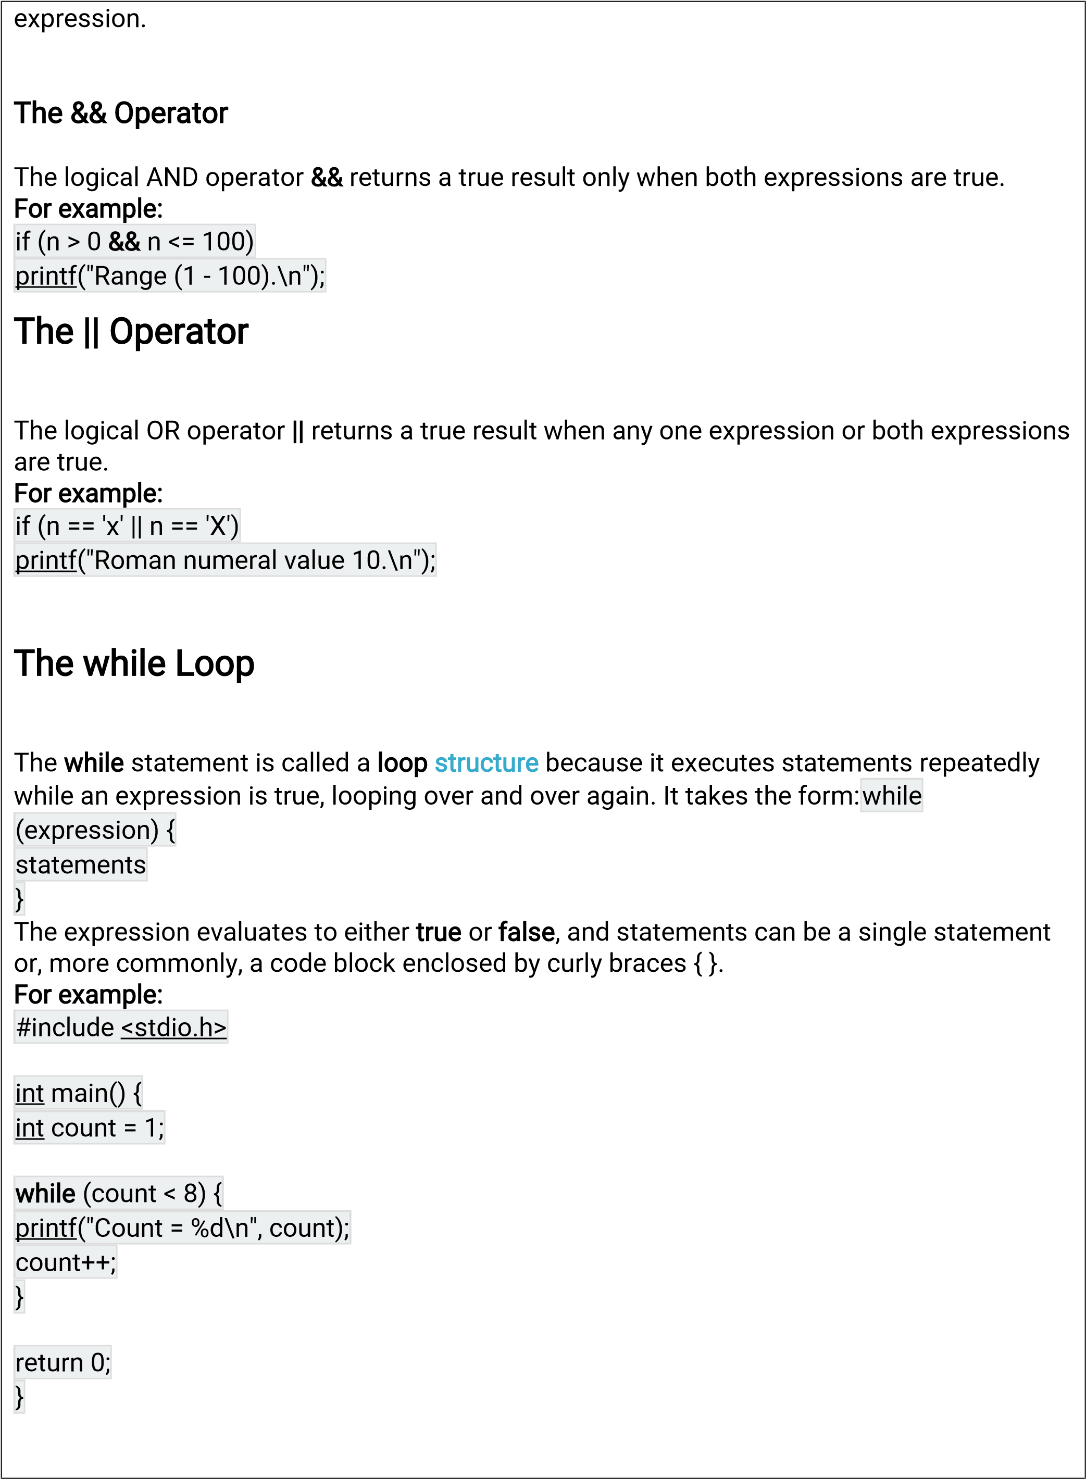

|  |  |  |  |  |  |  |
| --- | --- | --- | --- | --- | --- | --- |
| The do-while Loop      The do-while loop executes the loop statements before evaluating the expression to determine if the loop should be repeated.   |  | | --- | | do { |   It takes the form: statements  } while (expression);  The expression evaluates to either true or false, and statements can be a single statement or a code block enclosed by curly braces { }.  For example:   |  | | --- | | #include <stdio.h> |     int    main()    {    int    count    =    1  ;      do    {    printf  (  "Count    =    %d  \  n",    count);    count++;    }    while    (  count    <    8)  ;       |  |  | | --- | --- | | return 0; |  | |  | |   }    break and continue      The break statement was introduced for use in the switch statement. It is also useful for immediately exiting a loop.  For example, the following program uses a break to exit a while loop: |